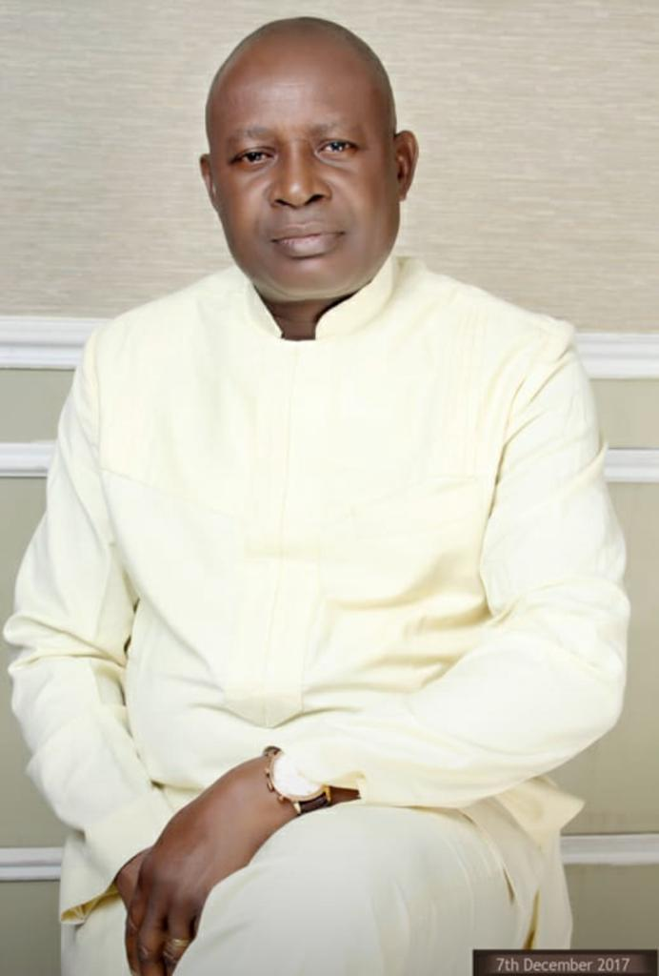

PROFILE OF

NNAMDI S. N. OKPU

Nnamdi Okpu, born about 64 years ago to Late Orlu Jeremiah Nwugo Okpu and Mrs Alice Leah Jeremiah of Ula – Upata Commuinty in Ahoada East Local Government Area of Rivers State, obtained the First School Leaving Certificate in 1972 and the West African School Certificate in 1977. He is a holder of the degree of Bachelor of Science in Sociology, 1984, of the University of Benin, Benin City.

After his compulsory national service under the National Youth Service Corps (NYSC) 1984 – 1985, he joined the public service of Rivers State in 1986 in the Administrative Officer Cadre. Through dint of hard work and discipline he distinguished himself as a high flier and was a Public Service Merit Award Winner in 1995. He rose steadily through the ranks and served in various capacities. He retired in 2020 as a Permanent Secretary.

A man of many parts, Nnamdi is a member of some professional organizations and associates with other organizations with purpose and direction, which are committed to adding value to human dignity. He is on the Board of Usamali Ekpeye Brothers Foundation Governing Council.

He is actively involved in activities of the church especially of the Church of Nigeria, Anglican Communion, as a communicant and a Knight of St. Christopher, Diocese of Ahoada.

He enjoys reading, cycling and tennis.

Nnamdi is married to Lady Beatrice and the marriage is blessed with children.

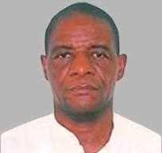

**PROFILE OF PROFESSOR DULU APPAH**

**Dulu Appah** is a professor of Petroleum & Gas Engineering at university of Port Harcourt. He is an acclaimed international petroleum and gas instructor, with extensive and expertise in production engineering research, management of complex governance issues that involve multiple stakeholders servicing high-level governance structures. He is a regular session chair, panelist and discussant at conferences, summits, workshops and professional interviews as an erudite academic, community leaders and a teacher’s-teacher.

**Professor Appah** is a Bureau for External Aids and Society of Petroleum Engineers (SPE) scholar (Region XII – Middle East and Africa), a Fulbrighter at The University of Oklahoma in Normal and a Humboldtian at ITE, Clausthal-Zellerfeld. He was previously Dean, Faculty of Engineering and Provost, College of Engineering; Professor Chi Ikoku Chair in Petroleum Engineering that researched into Fines Migration and currently PTDF chair in Gas Engineering that studies Gas Utilisation, transportation and leak detection. **Appah** is the Director, Institute of Petroleum Studies (IPS) at the University of Port Harcourt.

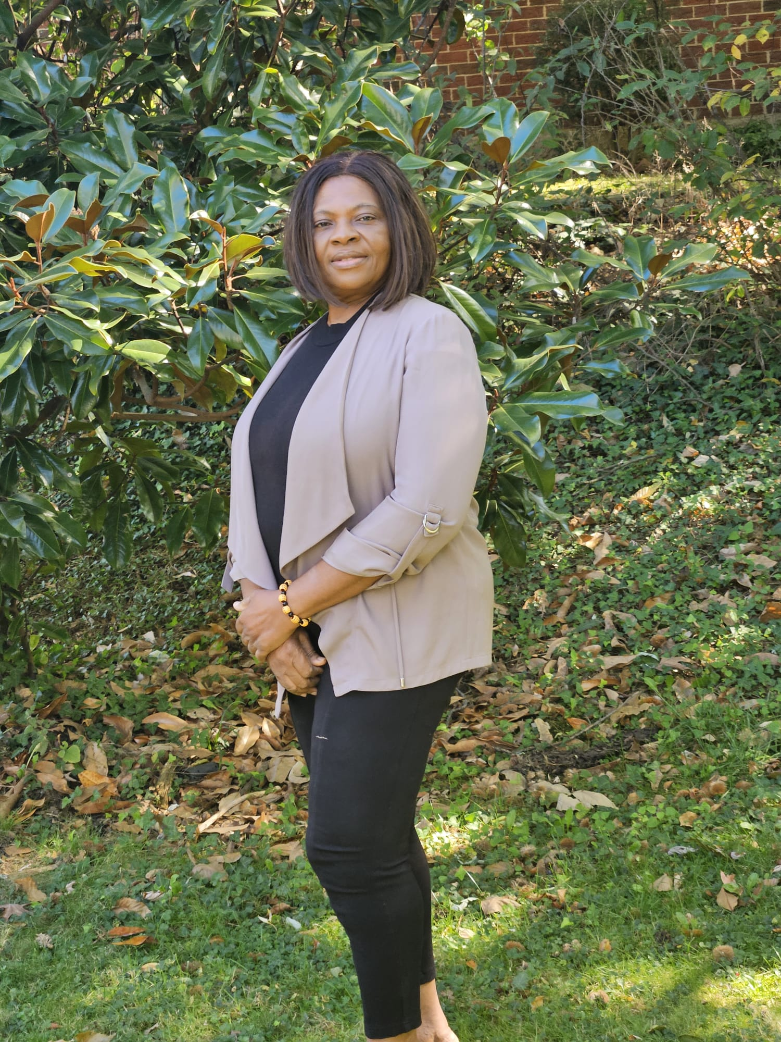

**Dr (Mrs) Theresa-Ogide Dinma Alaeze**

**BIO-PROFILE**

**A LEADER IN PREVENTION HEALTH CARE**

A Nurse Practice Educator and infection Control Specialist with PhD in Public Health, Master’s degrees in Health Service Administration/Community Health (Dual), and bachelor’s degrees in Nursing, School Health, Special Health Education (Dual).

With over 30 years of experience in program planning, implementation, monitoring and evaluating, including fiscal management/ budget oversights for government, non-profit and private organizations. She have served in various capacities assisting organizations to identify specific quality indicators, quality improvement assurance plan and performance outcome measures.

Founder & President of the Associated Health Resource Center (AHRC) (2000)

Served in various capacities with the State Department of Health as: HIV/AIDS Prevention Director, Health Service Administrator Program Monitor/Compliance, Director, Tobacco Use Prevention Program, Health Policy Analysis, Train-The-Trainer & consultant. Also still teaching for 15 years as core Adjunct Faculty-higher institutions.

**Expertise**

* Advocate for social-justice for the medically under-served populations
* Qualitative Research
* Quality Assurance Management; Strategic Planning/Training and care Management
* Community and population health focusing on maternal-child health
* Community Mobilization & Need Assessments
* Educator (Higher Institution) & Training on social-health topics
* Forensic Nursing/Clinical Nursing Instructor
* Curriculum Development & Strategic Planning
* HIV/AIDS & Infectious/Communicable Diseases
* Health Policy & Compliance
* Program Planning, Implementation and Evaluation
* International Health & Resource Identification/allocations
* Education (Higher Institution) & Training on Social-health topics

While we strive to increase equitable access to social-health in the global community, her work embodies researching out to the hard-to-reach population and the social-medical under-served (Poor, marginalized & individuals with special needs) at the grass root level.

**A BRIEF PROFILE OF**

**HON. (MRS) FAITH S. PRINCE ESOR**

1. **Birth:**

Hon. (Mrs) F.A.P Esor was born into Izubene family of Umuzhi in Odiabidi town in Ahoada East Local Government Area of Rivers State on the 29th of October, 1970 to late Chief S.O. Nwebedu.

1. **Educational Background**

She attended Santana Primary Boarding School Awomanma Imo State between 1975-1981 where she obtained her first school leaving certificate. She then proceeded to the prestigious Holy Rosary Secondary School, Port Harcourt between 1981-1987, where she obtained her West African School Certificate (WASC).

The quest for higher education took her the then College of Education, Rumuolemeni, Port Harcourt, now Ignatius Ajuru University where she graduated with an NCE in fine and applied arts in 1993, having gained admission into the then College in 1989. She went further to obtain a B.Ed degree in education at the Imo State University Owerri in 2016 having gained admission into the school in 2011.

1. **Working Experience**

1. She is the Proprietress of Angels Montessori Group of School (Government Approved) in Okogbe, Ogbo, Alahakia and Ahoada between 2004 till date, by a space of seventeen years.

2. A poultry farmer between 1992-1999.

3. A reputable farmer between 2019-2021.

4. Producer of Angelic board solution (producers of writing chalk) 2011 till date.

5. A two times Councilor representing ward 7 in Ahoada west local government area where she become the deputy leader of the legislature assembly between 2007-2013.

1. **Christian Life**

She gave her life to Christ in 1988 at United Baptist Church Ahoada and has remained in the faith. She had held several positions at United Baptist Church, Ahoada, Ekpeye/Ogbogolo Baptist Association, the Rivers Baptist Conference and the Nigerian Baptist Convention.

1. **Marital Life**

Hon. (Mrs) Faith A. Prince Esor got married to Dcn. Dr. Prince B. Esor of Uchi family of Emezi 1 Community in Ahoada West Local Government Area of Rivers State in December, 1994 and have therefore, by God’s grace spent 27 year in marriage. The marriage is blessed with five children both boys and girls.

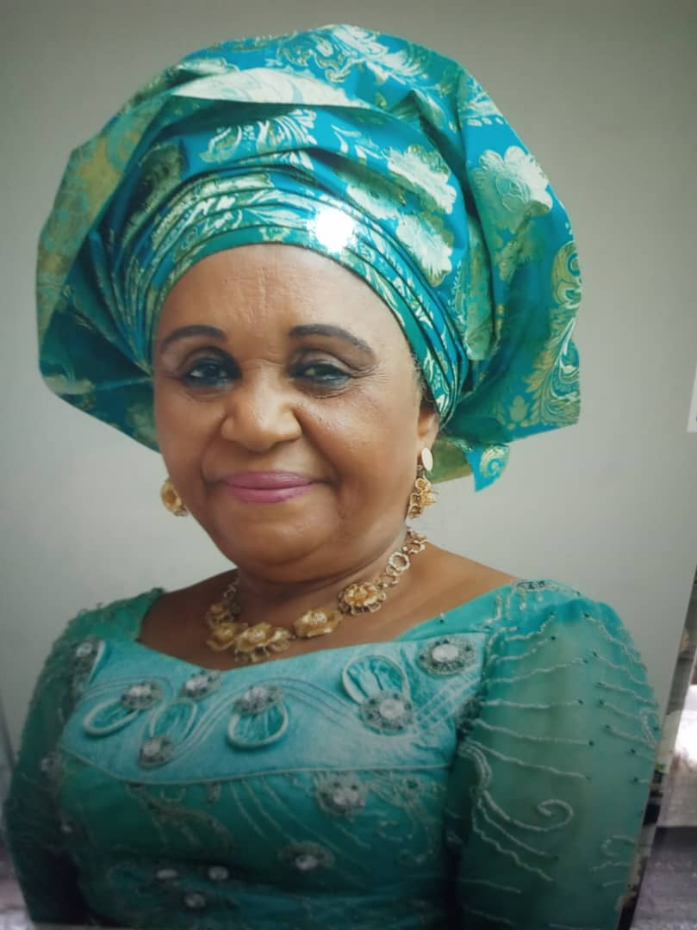

**Dame (Hon.) Joy Oguzor's Profile.**

With a professional career spanning over 35 years, Dame Joy Oguzor has made her mark as a dedicated public servant and pioneer in local governance. Starting her career in the 1970s after completing her tertiary education, she entered the hospitality industry, where she quickly rose to managerial positions, including running and managing the Catering School of Delta Hotels Group in Rivers State.

In recognition of her hard work and integrity, Dame Oguzor was appointed by the Governor of Rivers State to serve in the Local Government Care-taker Committee of the old Ahoada Local Government Area (LGA) in 1993. This appointment launched her into public life, and she later became the first and only elected female Local Government Chairman within the entire Orashi region in Rivers State till date, and subsequently, the first Chairman of Ahoada-East LGA after its creation. Her leadership and landmark achievements remain a reference point, inspiring many women and men to pursue careers in public service and politics.

Beyond her professional and public life, Dame Joy Oguzor is a devout Christian and active church leader. She serves as a Lay-reader in the Anglican Communion, a Patron of the Boys Brigade, and a Knight in the Church of Christ. Her commitment to the Lord’s work and the growth of the church is evident through her various church committee roles.

A champion of social service, Dame Oguzor supports several charity groups, particularly those focused on widows. She has served on numerous boards and associations both locally and nationally and continues to contribute to the betterment of her community.

Dame Joy Oguzor is happily married and blessed with children and grandchildren.

Profile of Buduzhi Gift Oguzor -Secretary Governing Council

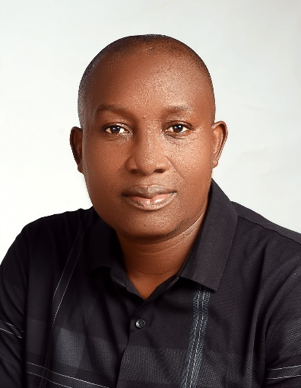

**Mr. Buduzhi Gift Oguzor has expertise in public health nutrition, programming, project management, advocacy, research, agribusiness, agro-processing and innovation. Nutrition Champion and award winner of BNFB Project and CS-SUNN Pooled Fund Project and** **has been part of implementation of high impact nutrition interventions with both government and donor funded programmes in Nigeria. He has used his wealth of professional experience to deepen the use of biofortified foods through product development and in management of malnutrition especially in children and adult in Nigeria. He is the Team Leader of Asa-Uwe Okporowo Ekpeye Farmers’ Co-operative Investment and Credit Society Limited (ASOEK-F-CICS) and CEO BUWA World Life Consult both producers of *Budu Foods* located in Port Harcourt. He served as State Nutrition Officer and currently State Focal Person on Basic Health Care Provision Fund at the Rivers State Primary Health Care Management Board. He is a member of Nutrition Society of Nigeria and National Association of Community Health Practitioners of Nigeria. Currently. At Usamali Ekpeye Brothers Foundation he is serving at various organs to ensure attainment of planned goals and mission.**

**Oguzor, Buduzhi Gift**

Secretary Governing Council Usamali Ekpeye Brothers Foundation/

Secretary Board of Trustee Usamali Ekpeye Brothers Foundation/

Secretary The Brothers Social Club of Ekpeye Ahoada East/West

Programme Manager/Programme Officer Usamali Ekpeye Brothers Foundation

Phone: +2348104037333, +2348132859499

Email: oguzorbuduzhigift@gmail.com, oguzorbg@yahoo.com

Instagram: buduzhioguzor

Facebook.com/buduzhioguzor

Twitter: #buduzhio

Linkedin: buduzhi gift oguzor

Skpe: BUDUZHI Oguzor